**Data Science**

**Experiment 3**

Name: Harsh Nevse

Division and batch: A1, A13

Roll and PRN: 31, 1032220463

Dataset and Analysis Information

* The dataset consists of information about two solar plants in India from:

Gandi Kotta, Andhra Pradesh and Nasik, Maharashtra.

* Parameters include: Power generated, DC yield, Total Yield, irradiation etc. All with respect to dates ranging from May to June in 2020.

**Analysis #1 – Power generated**

Average Power generation of the two plants over the date range provided is compared weekday wise and the maximum and minimum power generating days are recorded.

Representation🡪 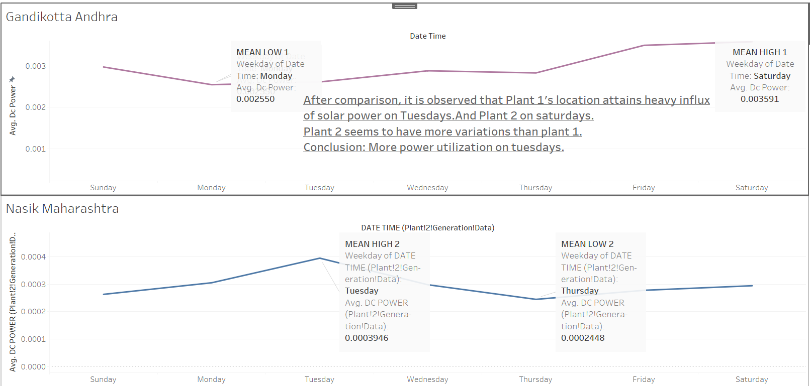

Observation ->

Plant 1's location attains heavy influx of solar power on Tuesdays. And Plant 2 on Saturdays. Plant 2 seems to have more variations than plant 1.

Conclusion->

More power should be utilized on Tuesdays.

**Analysis #2 – Inverter performance**

Firstly, the average irradiation observed for both plants is taken weekday wise.

Irradiation is the measure of the intake of radiation of an inverter.

Secondly, the average power generated by EVERY inverter in both plants is mapped colour wise.

Observation🡪

Observing them one over another, we can see if the inverter is generating proportionate power to the irradiation. It will help us to see the performance of the inverter. If an inverter is not producing much power on an otherwise high irradiation time, it might be faulty and can be opted for checking.

Conclusion🡪

It is observed that inverter coded 'bvBOhCH3iADSZry' is underperforming at higher irradiation compared to other inverters. Hence can be opted for repairing.

Representation🡪

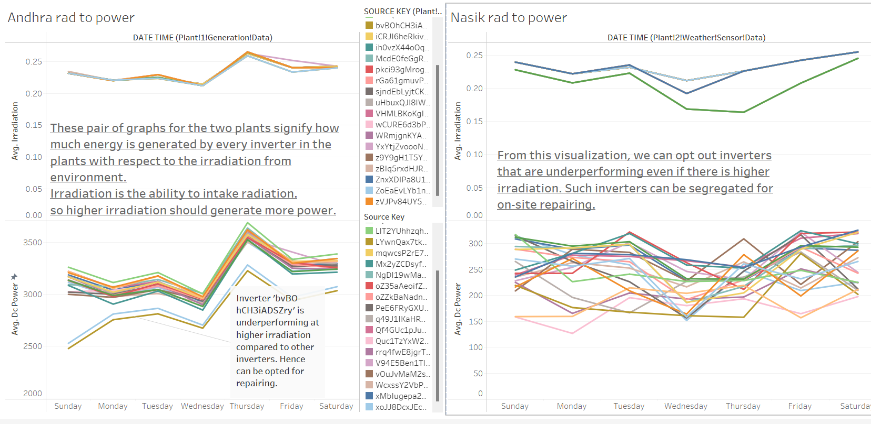

***THANKYOU***